**Data Migration from On-Premise to Microsoft Fabric Using Data Gateway**

Name & Batch: - Nachiket (C19) NCPL

**Project 1: Data Migration from On-Premise to Microsoft Fabric Using Data Gateway**

Step 1: In SSMS created tables:-

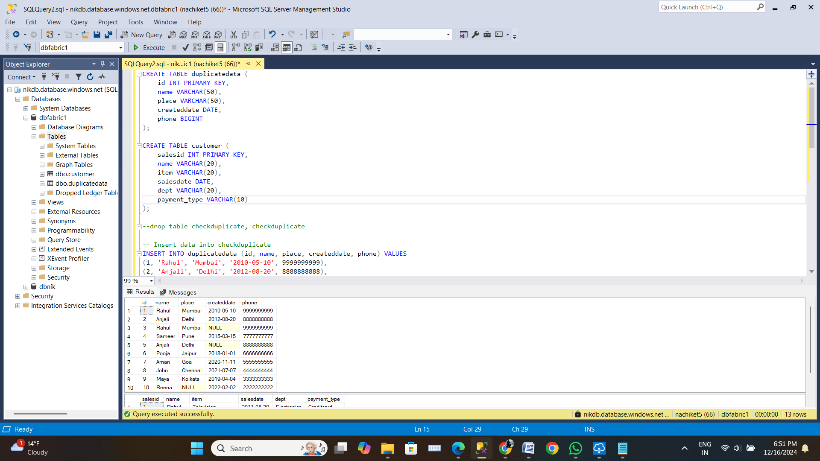

Step 2 : Downloaded Data Gateway

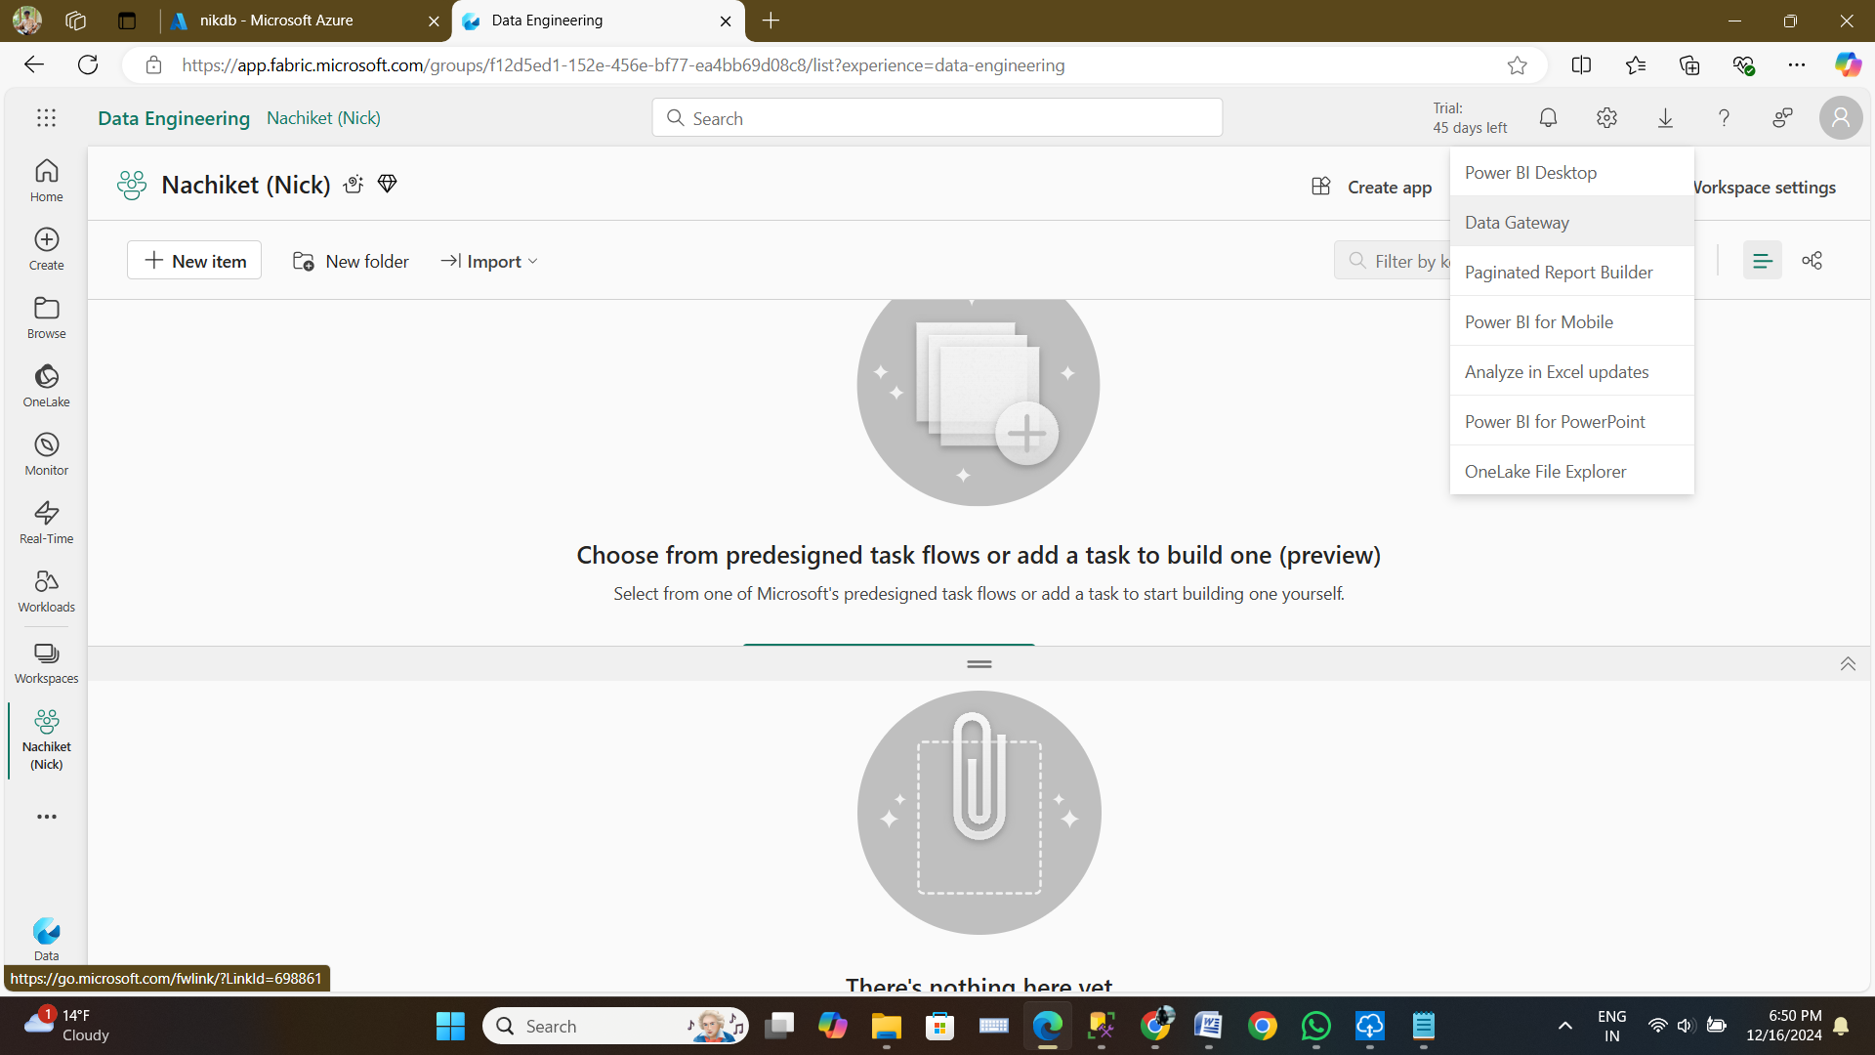

Step 3 : Once Download gets completed we need to provide same Fabric owner email account to register it.

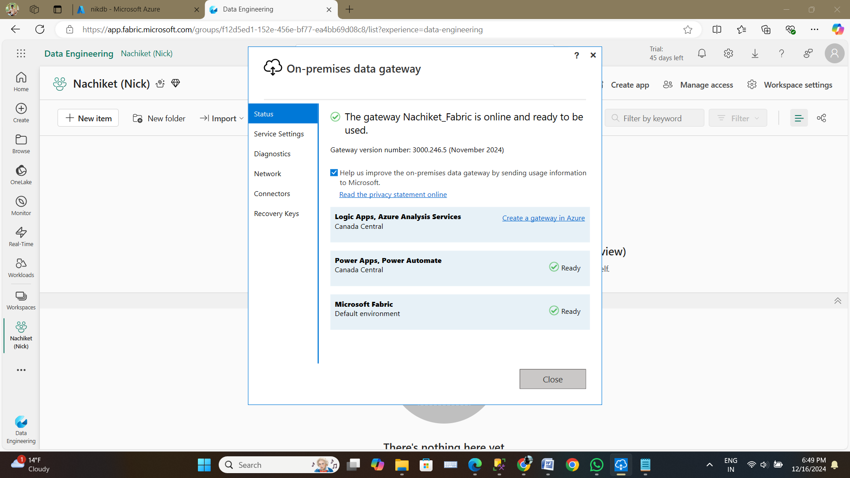

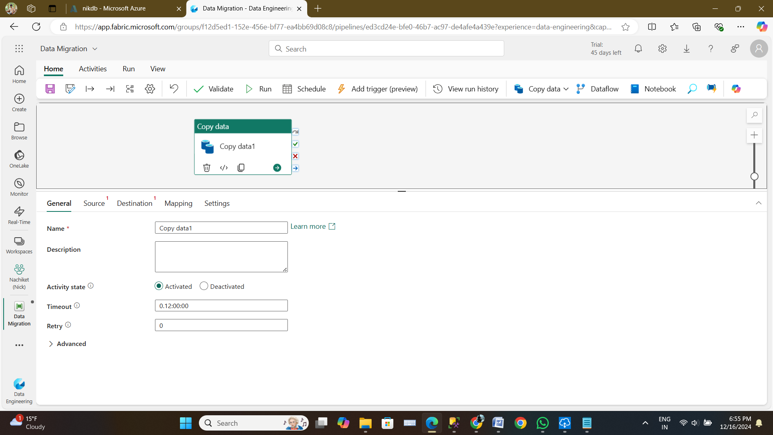

Step 7 : Connect to a data source

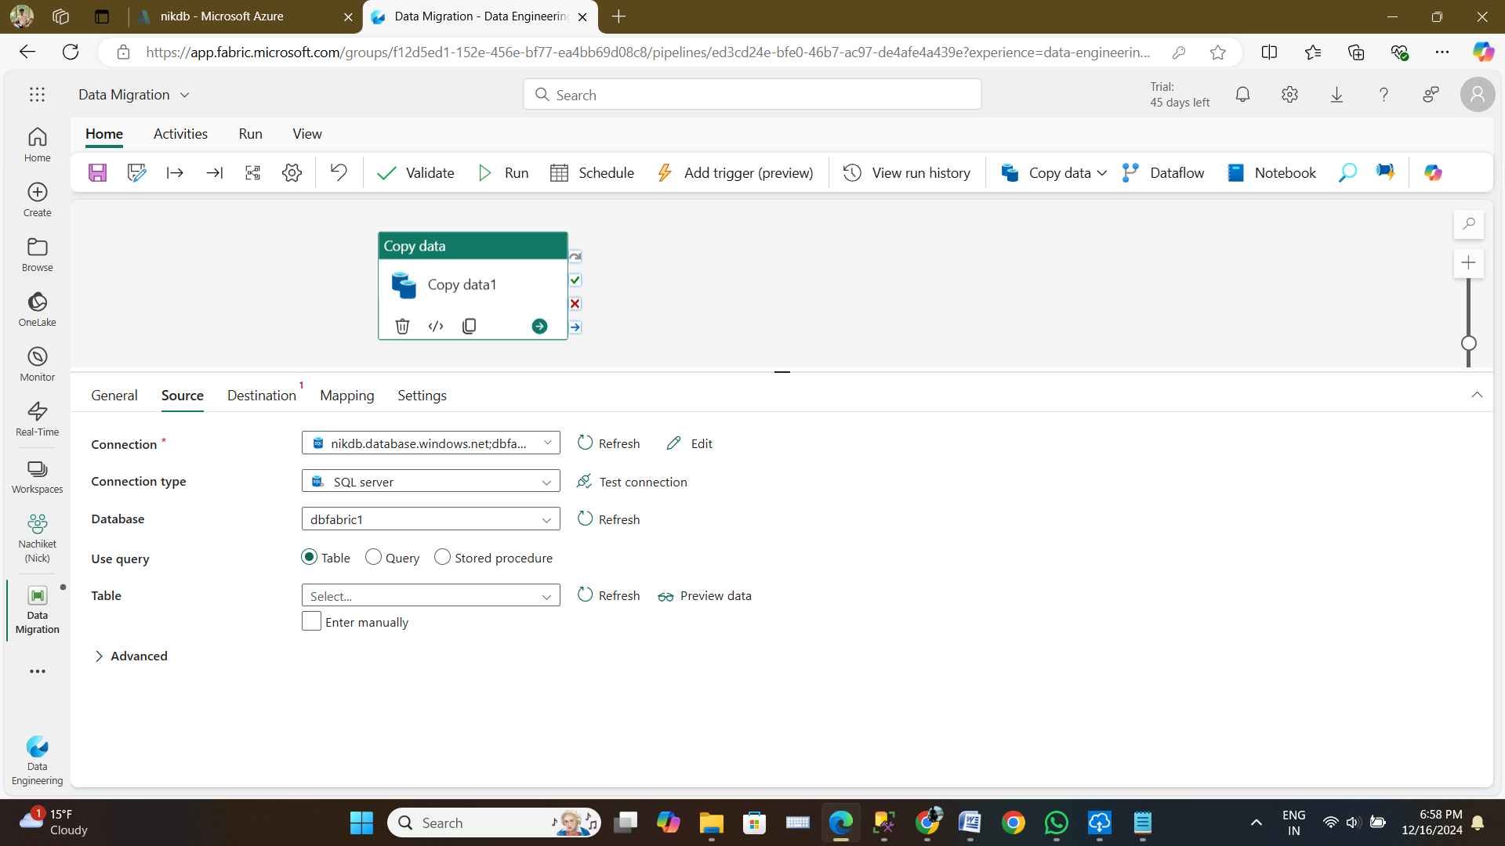

Step 11 : After that checking the pipeline

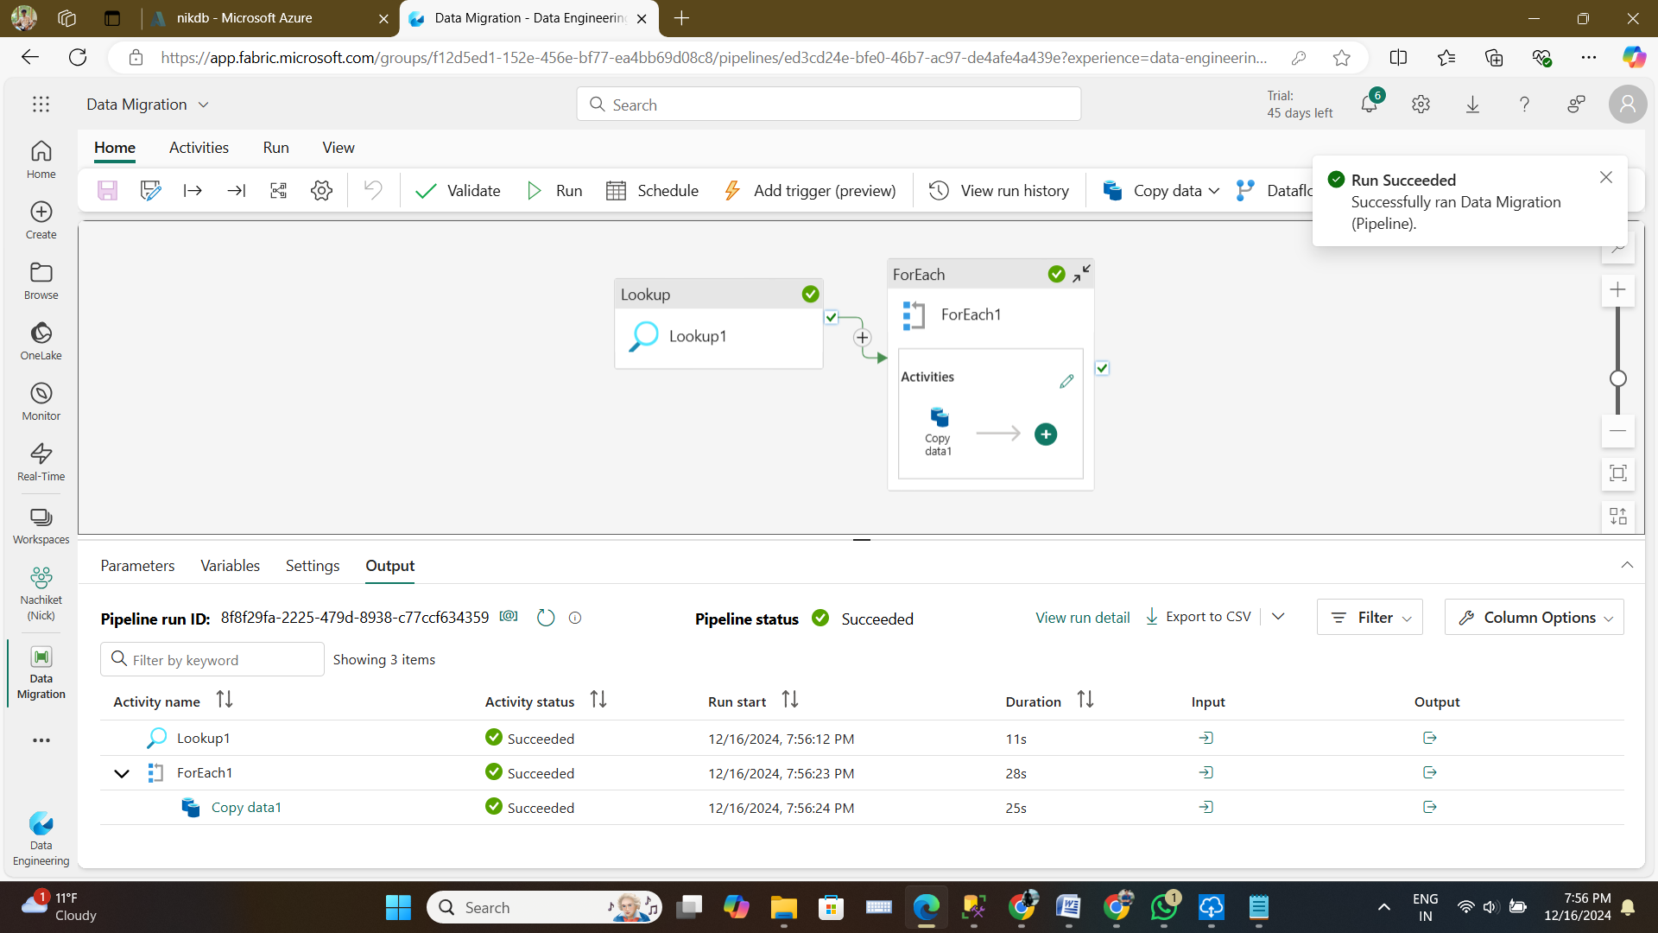

Step 12 : After this went on to Lakehouse and checked both tables

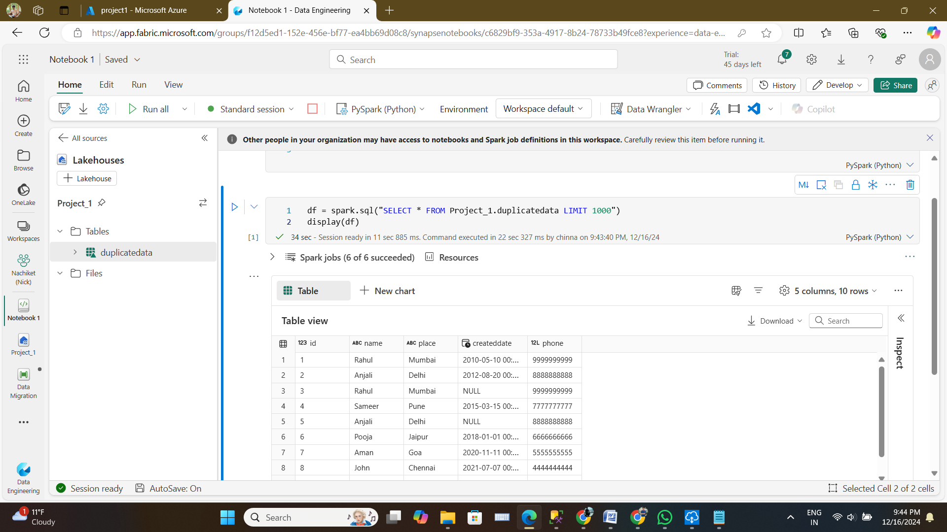

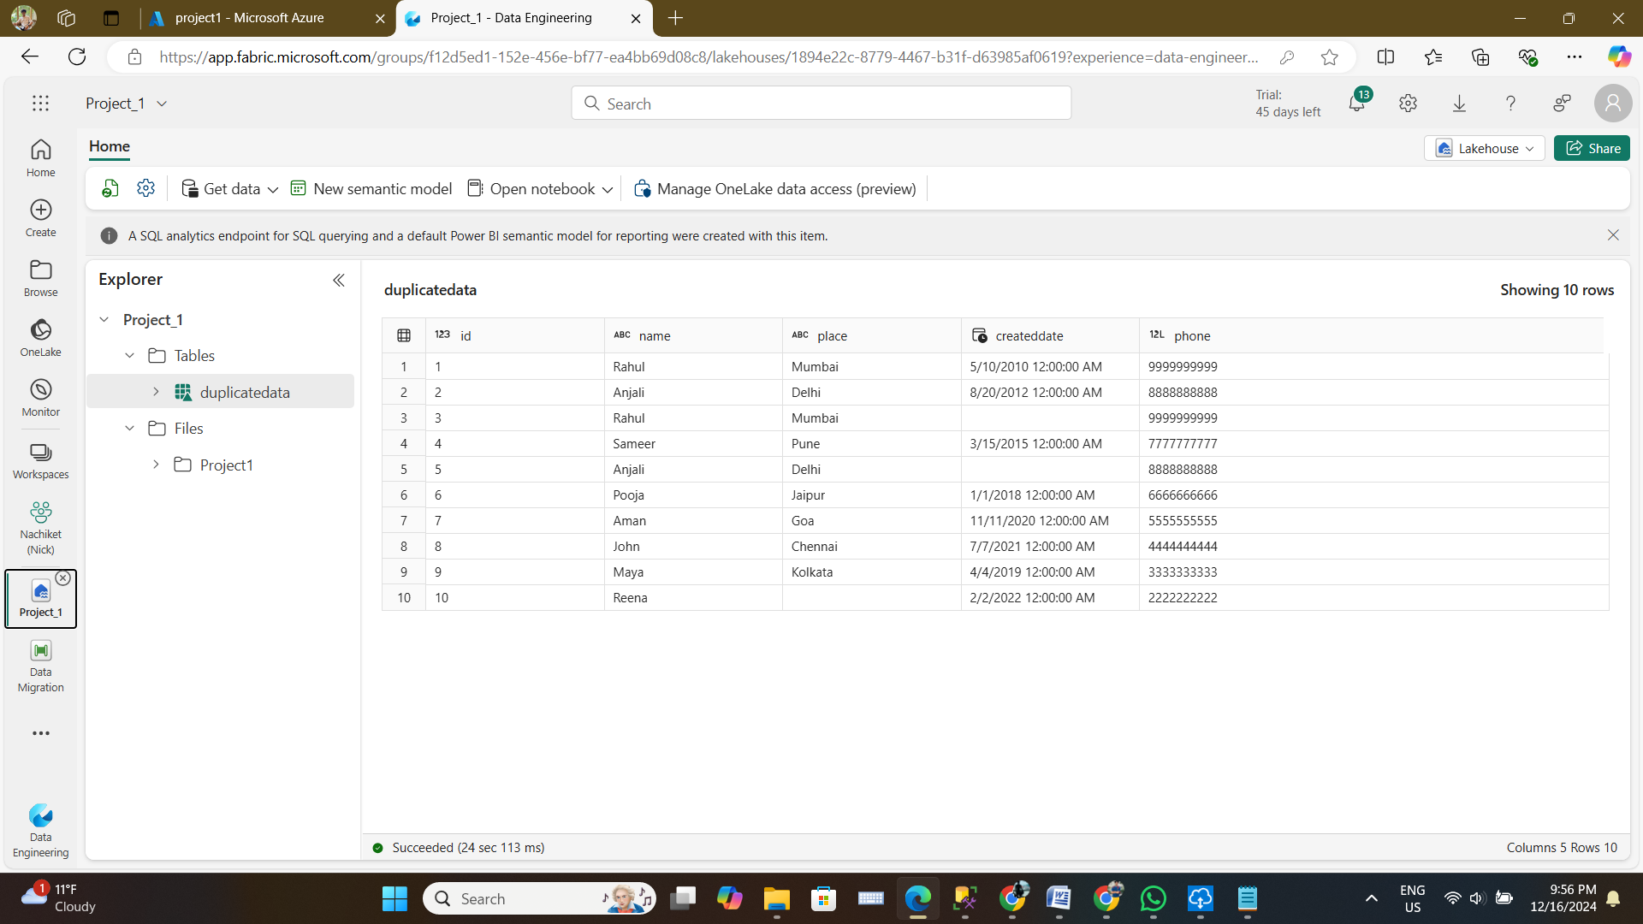

**Second table**

Step 13 :Also checking the same data with help of Data Pipeline

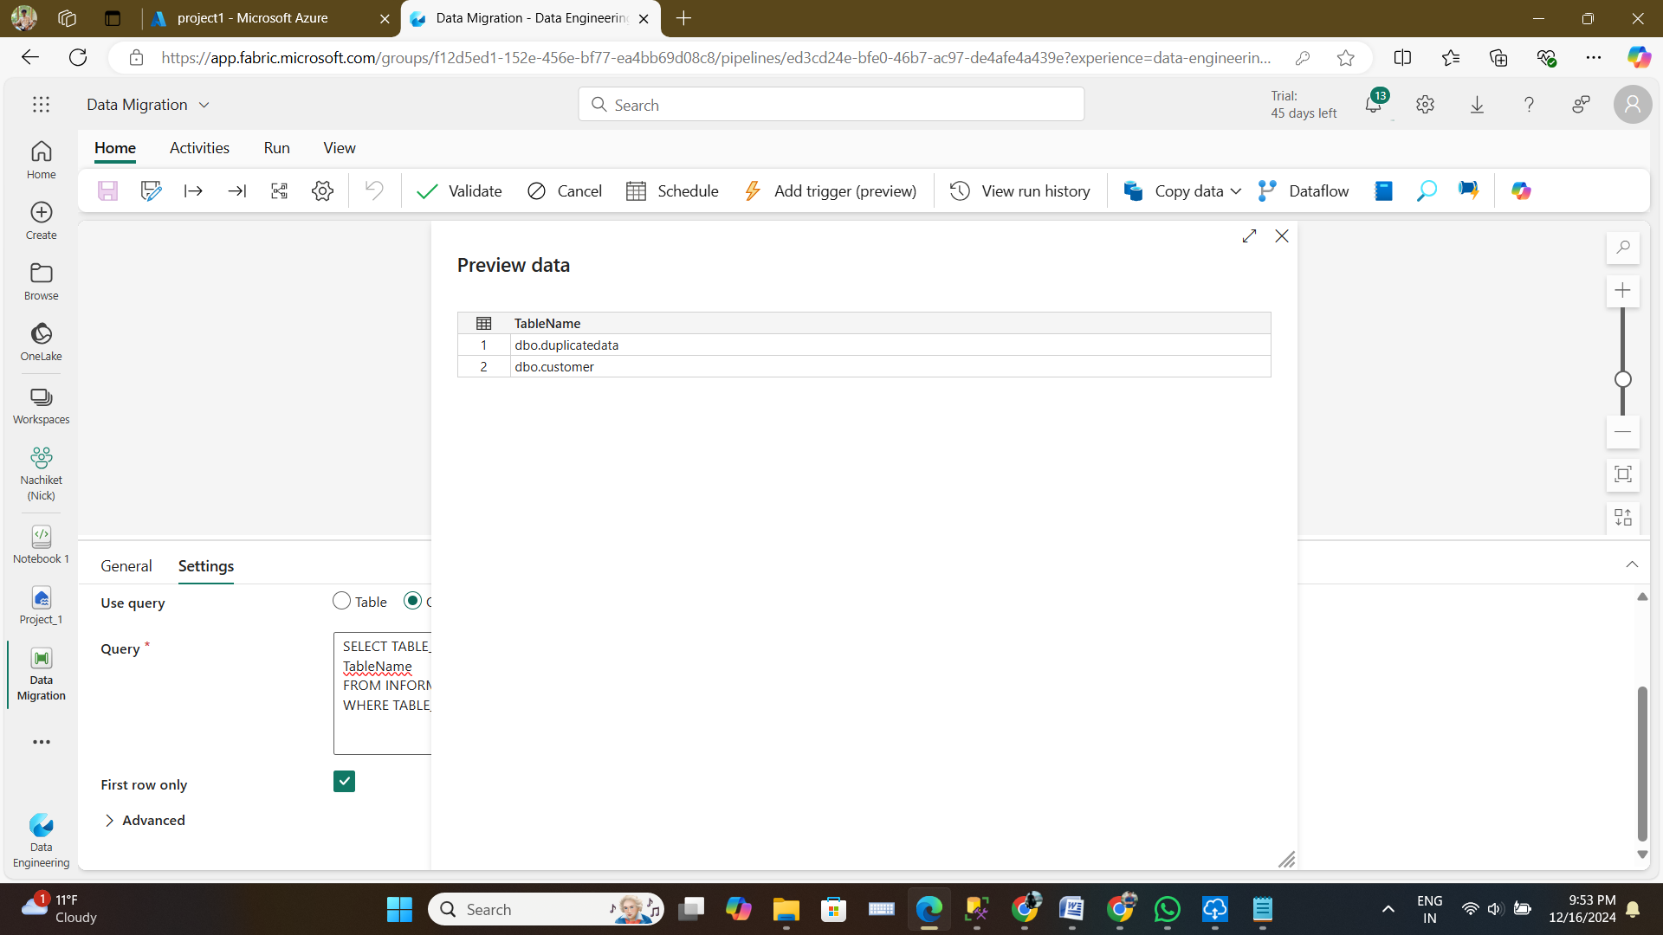

Step 16 :And in Destination selecting the txt files in the lakehouse

Step 17 : Now checking the file with txt extension in lakehouse

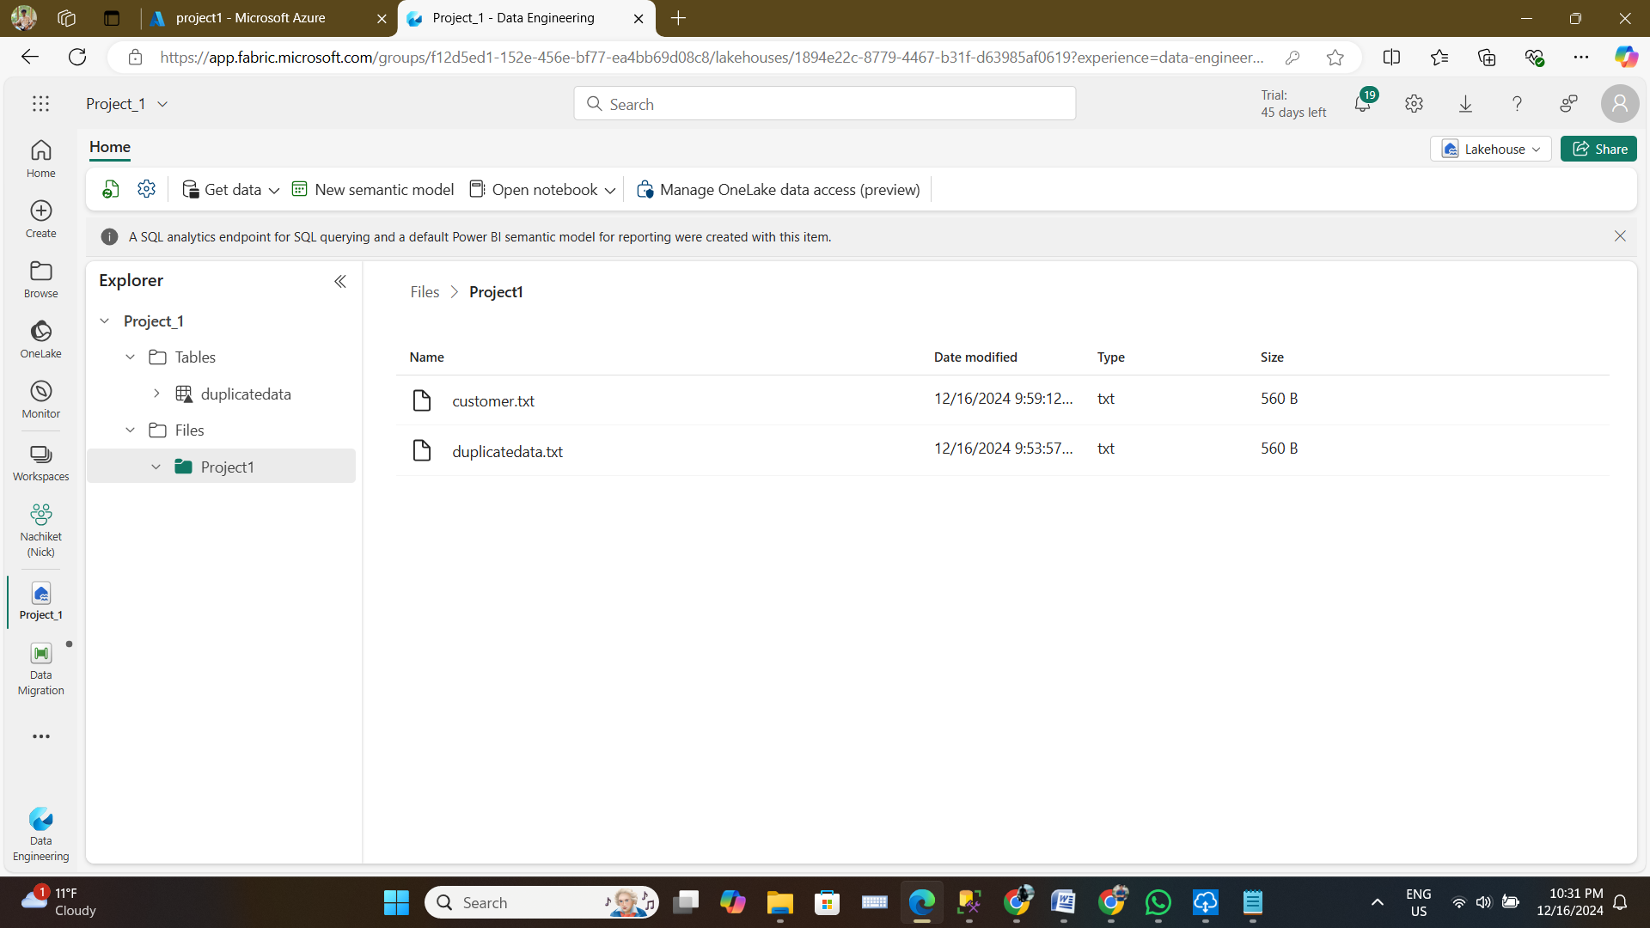

Step 18 : Checking the content of the file

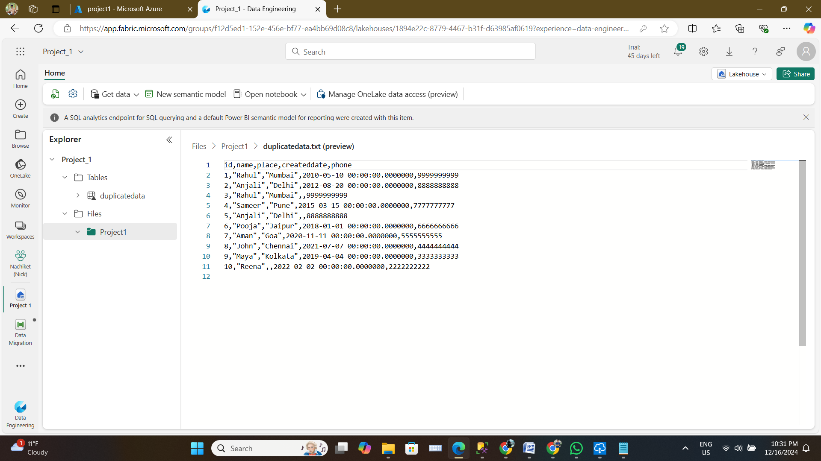

**After this added one more record to the table and refreshed the data by running the pipeline to check whether it retrieve the records or not.**

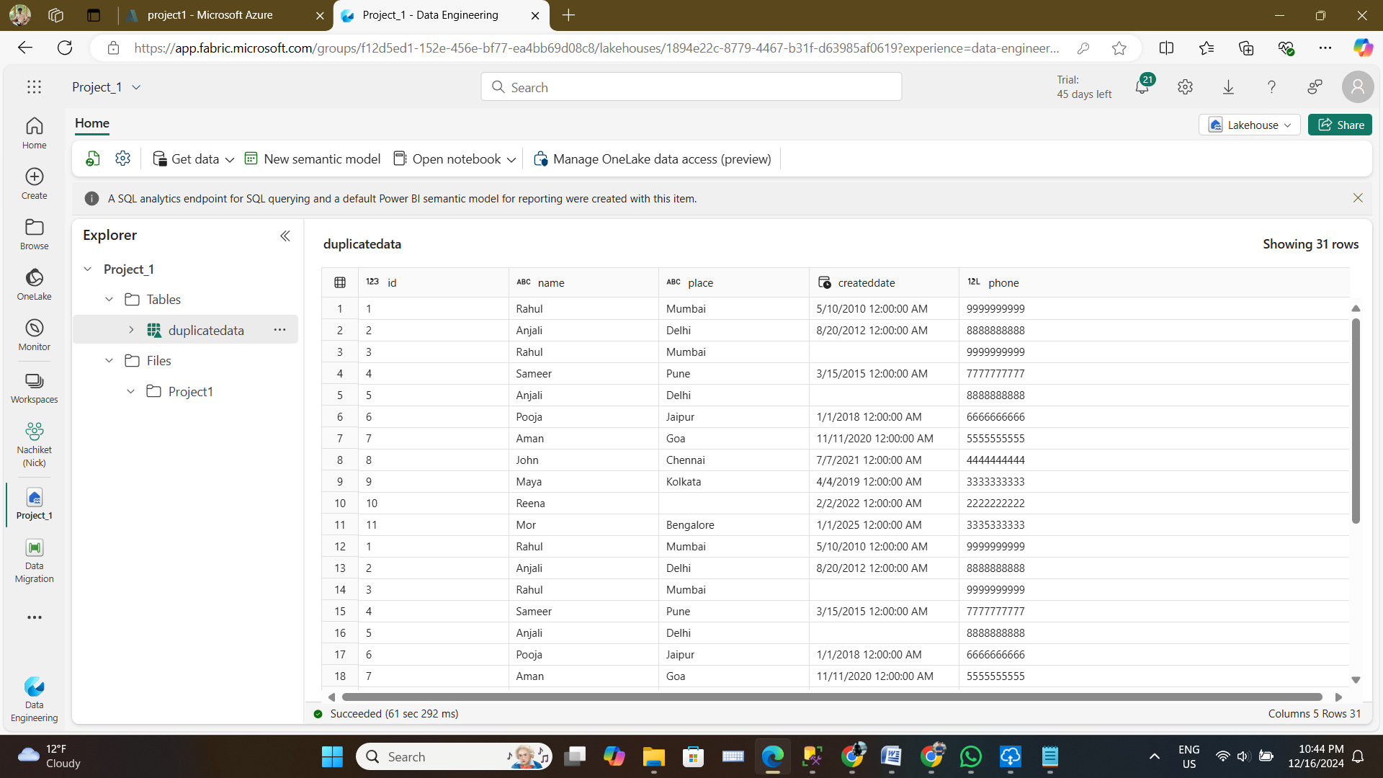

**Extra Project 2 : Ingest Data from Azure SQL Database to Lakehouse in Microsoft Fabric**

Step 1 : First Create any table in Azure SQL Database like here below :-

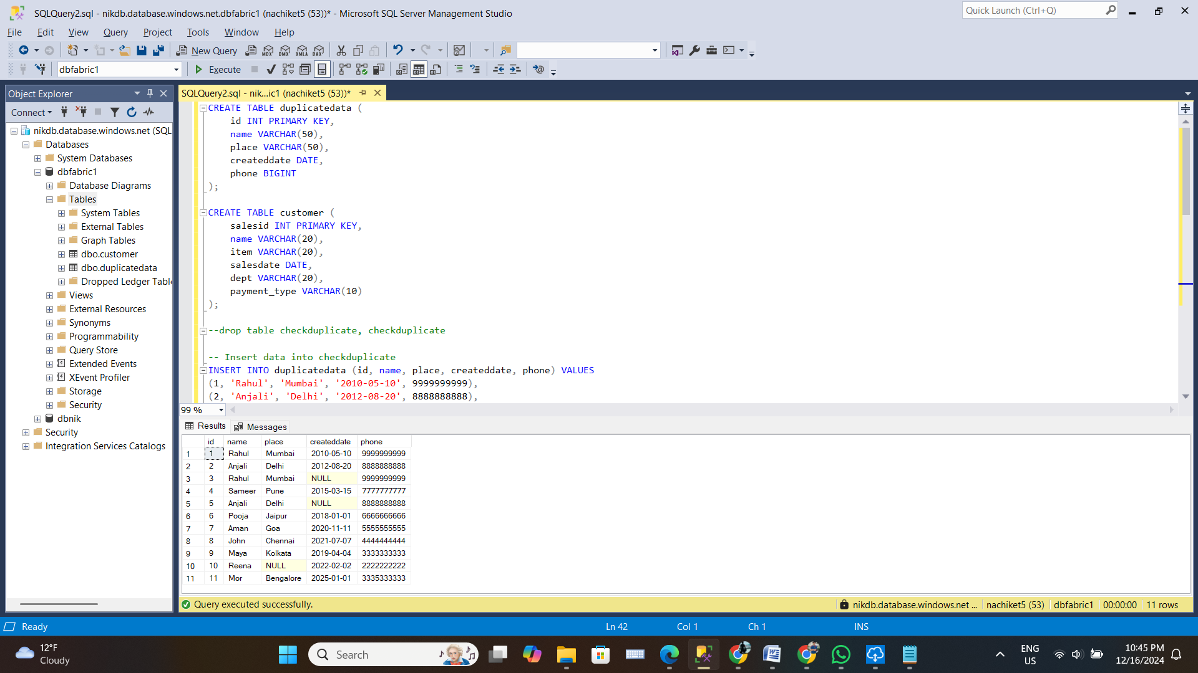

Step 4 : Since I have used Dataflow Gen2 hence I need to source data from other sources like here below:-

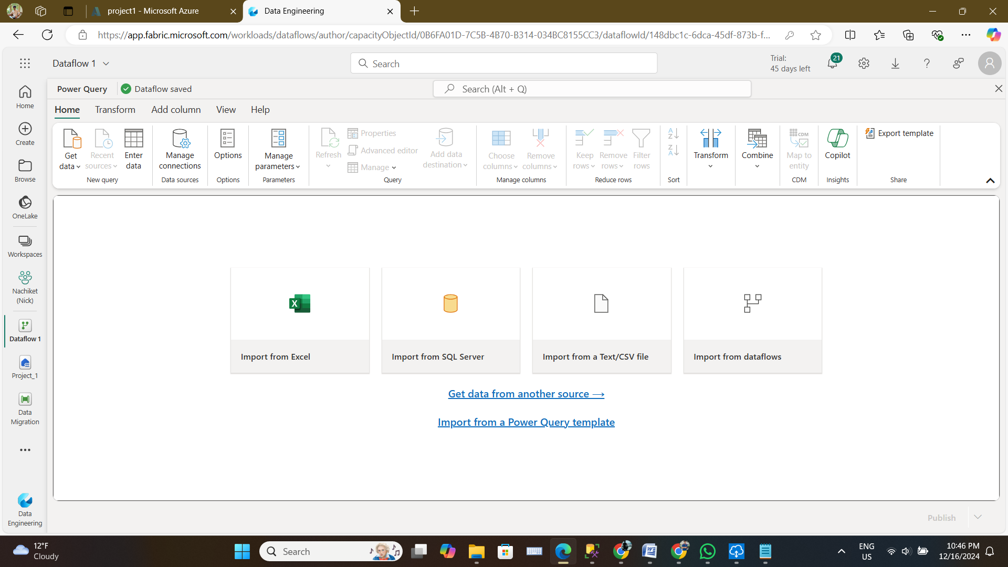

Step 7 : Select the Table and click create below :-

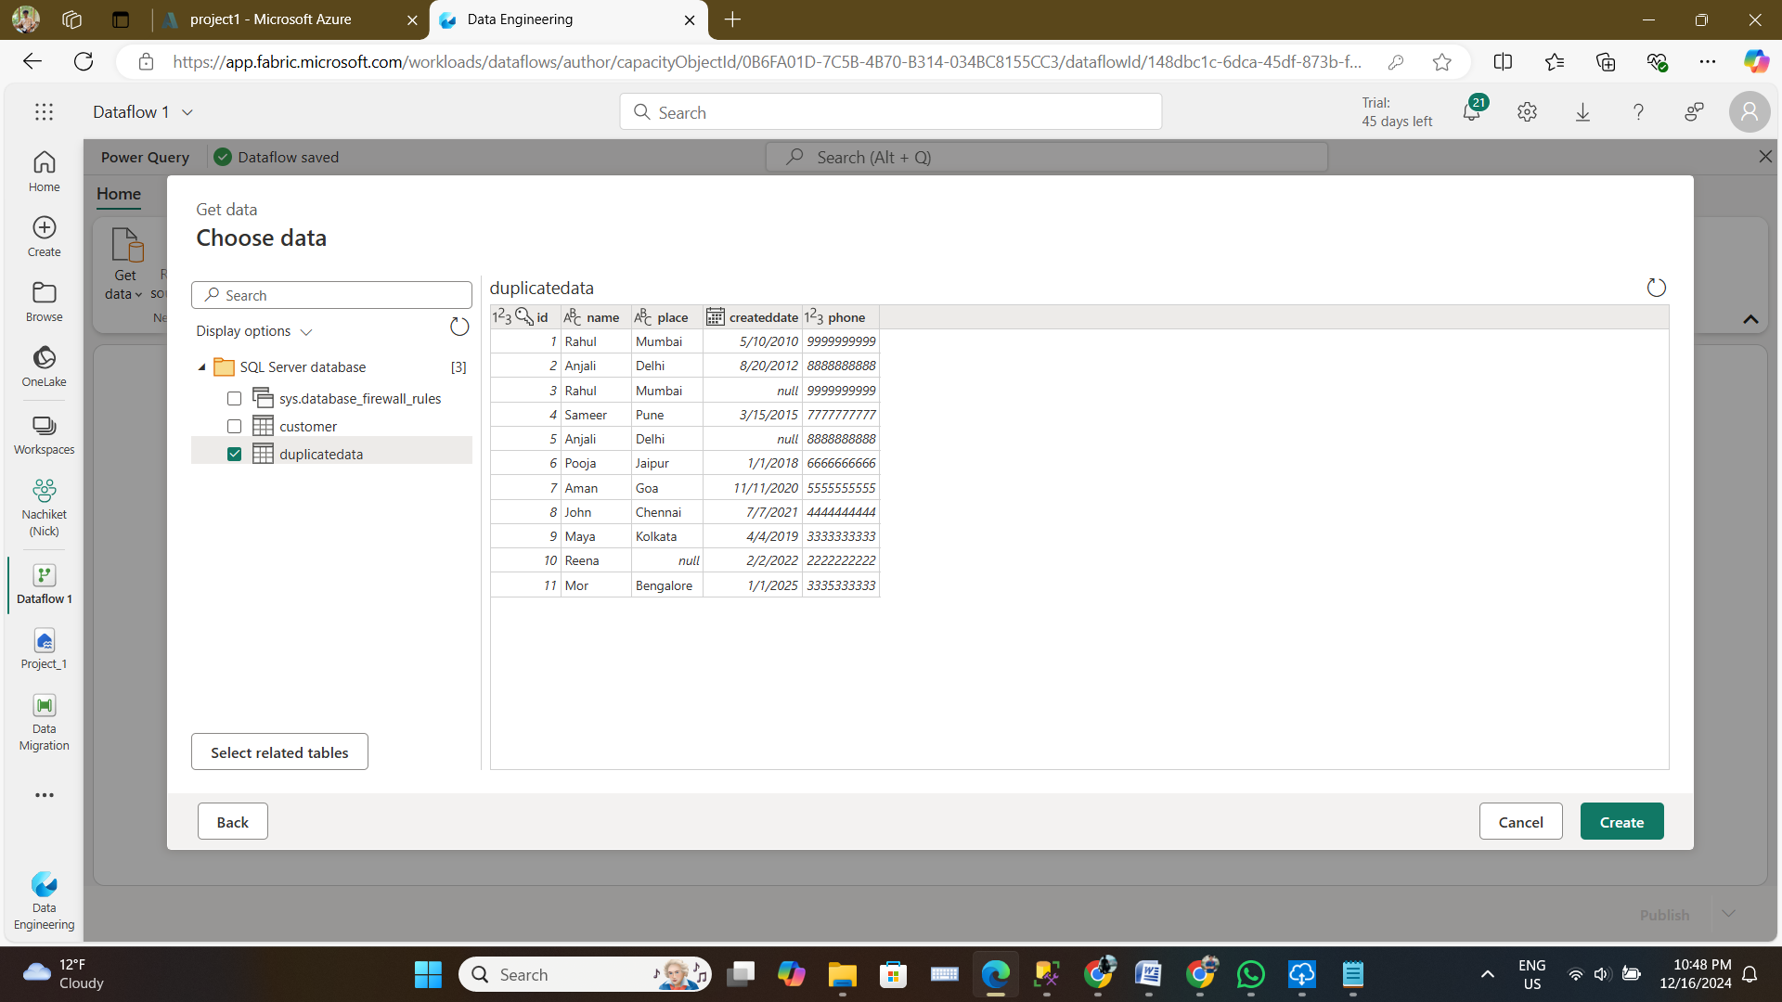

This is how it looks once you create the table

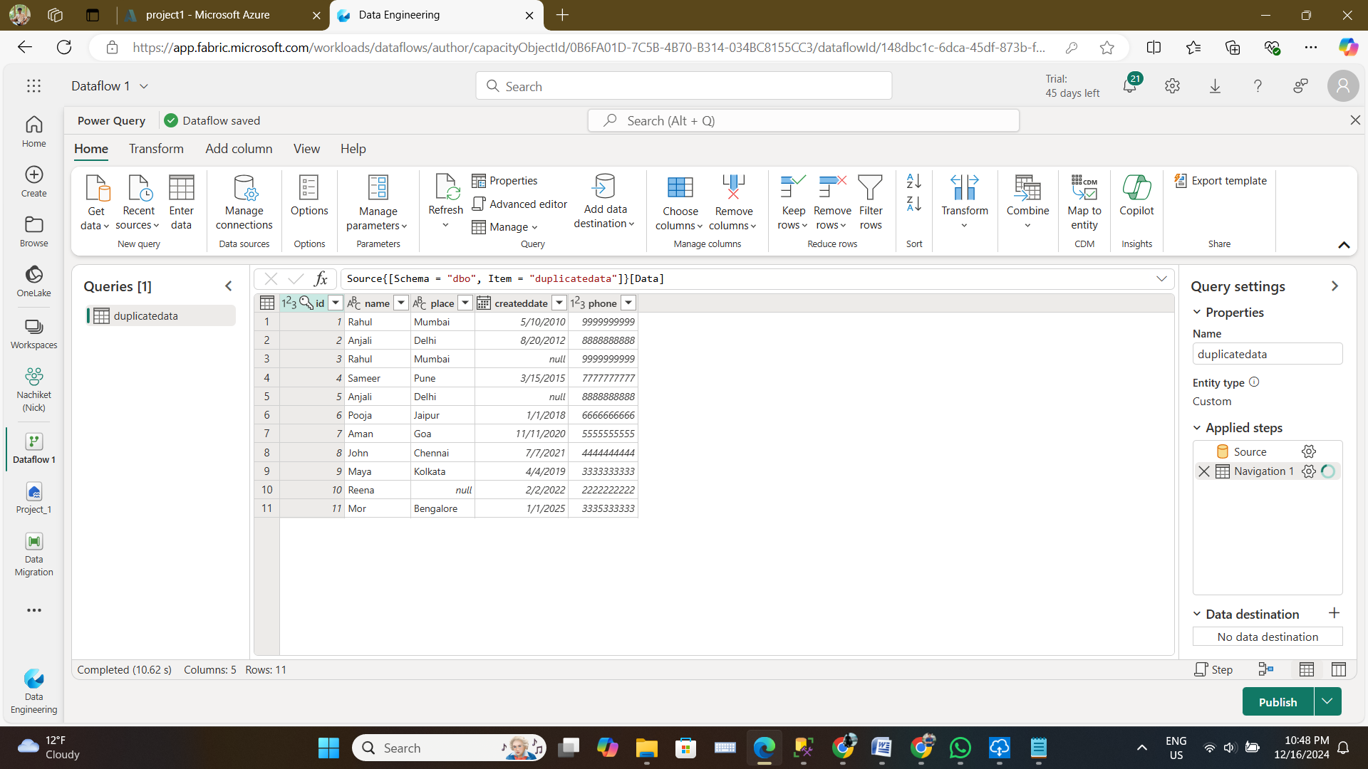

Step 10 : As we have many other workspaces for different student hence I can select mine workspace and load the destination target as Nachiket to load the data.

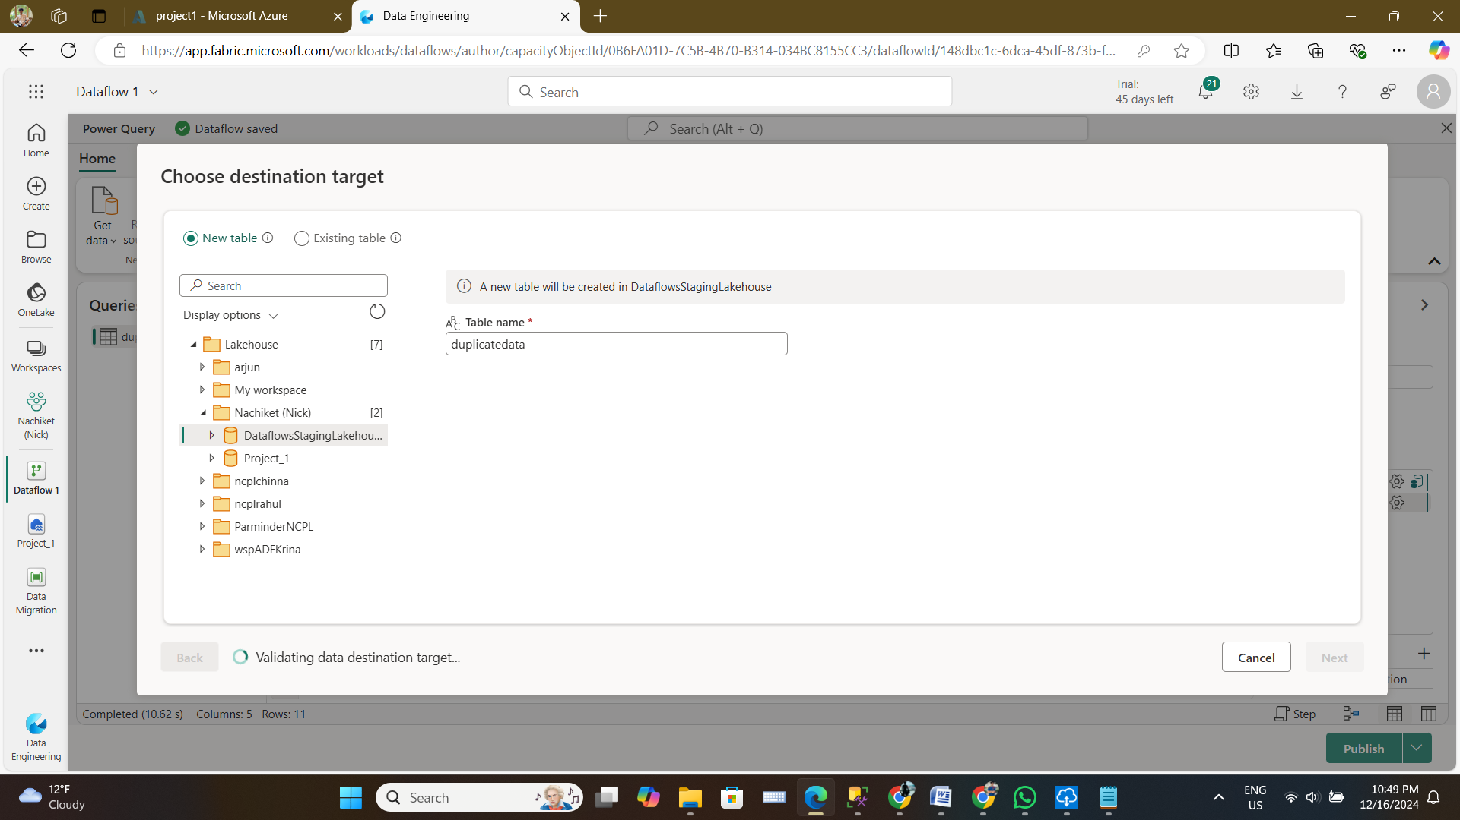

Step 12 : This publish the data and they are always getting refresh to bring any changes to datalakehouse in case if this had done at source

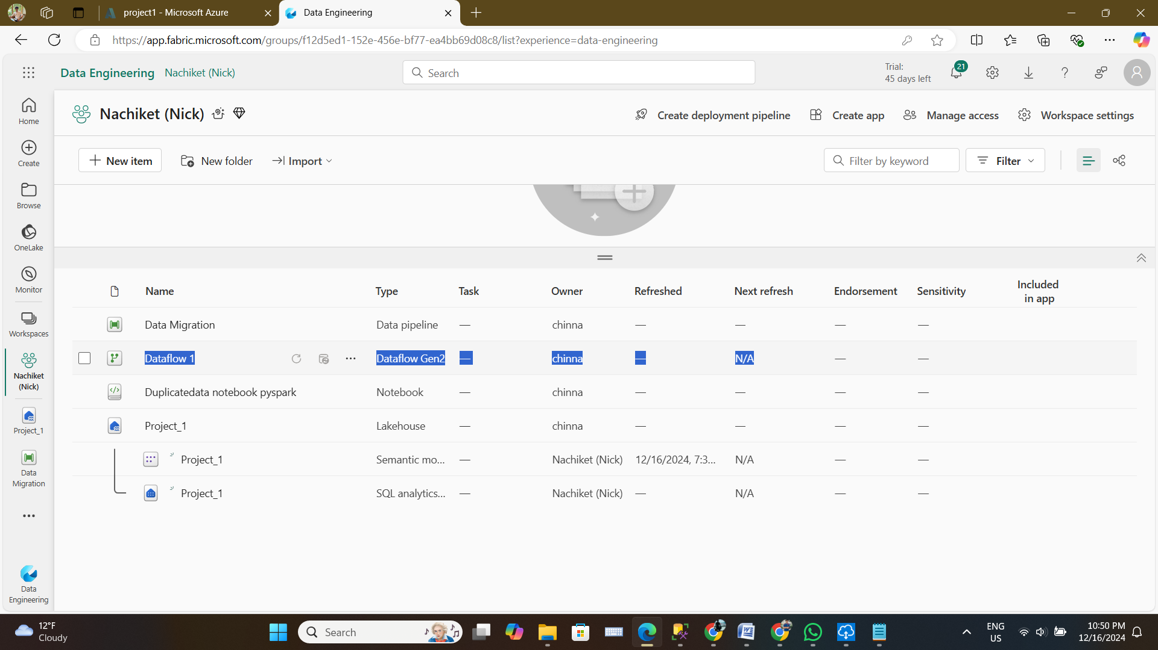

Step 13 : Now will insert new data to same table and after refreshing in Fabric we can see the new row of appears in the table in Fabric

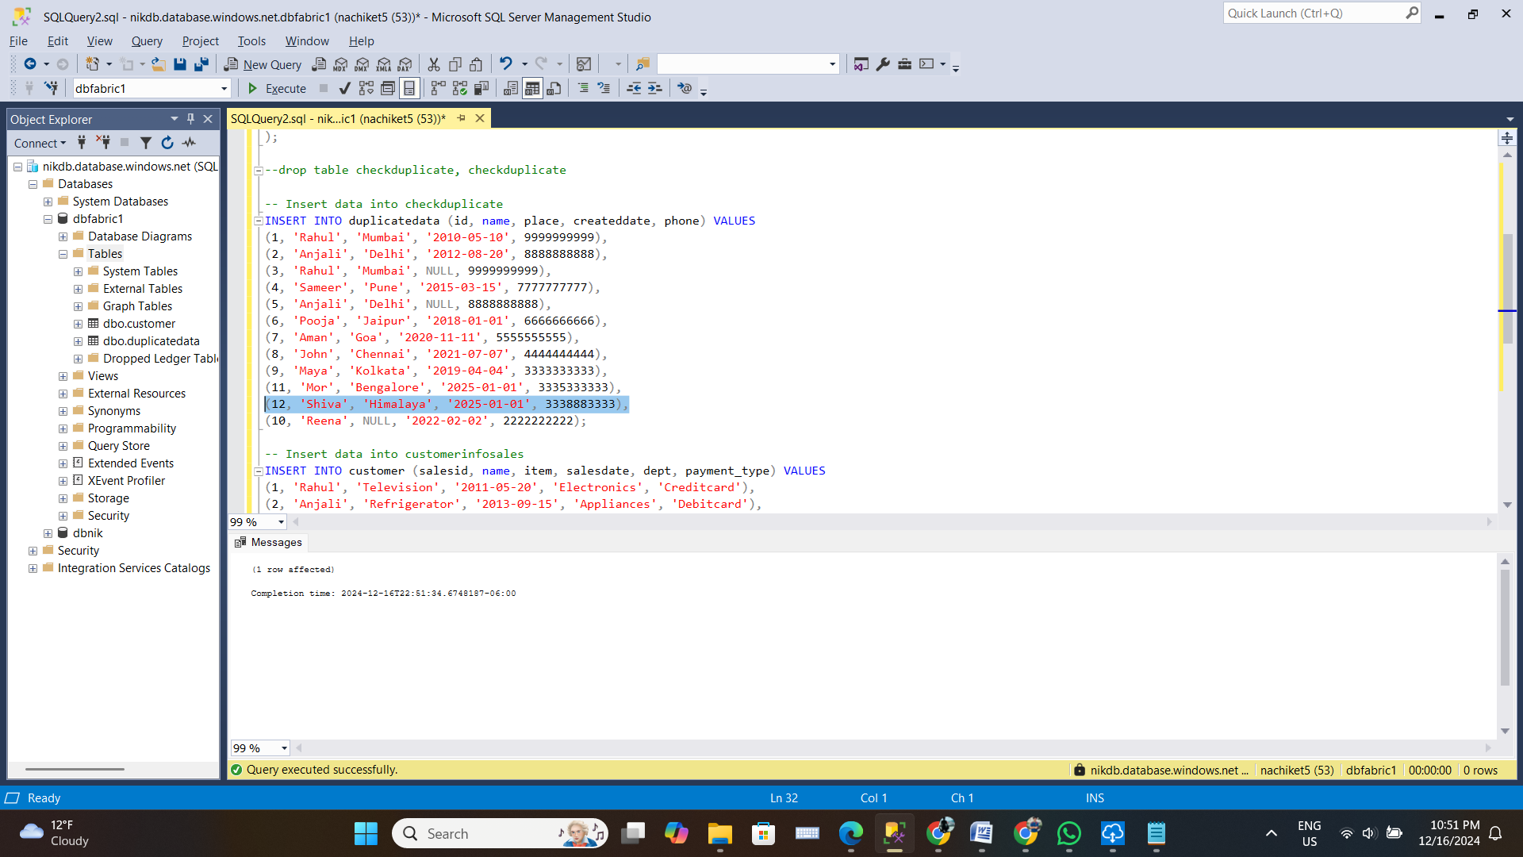

Step 14 : Refresh the data and look for new record which was just inserted.

